Tandridge Boundary Review Consultation Closes 7 August 2023 Email reviews@lgbce.org.uk
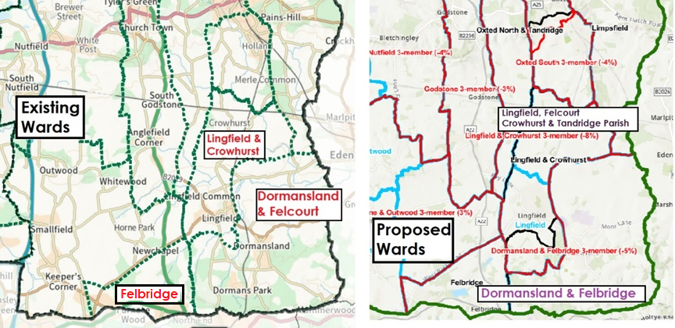
Existing Wards | Numbers of councillors | Electorate | Electorate per councillor | Area  Km2 | Proposed wards | Numbers of councillors | Population | Electorate per councillor | Area  Km2
Lingfield Crowhurst | 2 | 3056 +  272 | 3328  ÷ 2 = 1664 | 5.67  9.7  15.37 | Lingfield,  Felcourt,  Crowhurst  Tandridge Parish | 3 | 3056  466  272  524 | 4318  ÷3 = 1439 | 8.67  9.7  10.99  29.36
Dormanland Dormans Park Felcourt | 2 | 1980  627  466 | 3073  ÷ 2 = 1537 | 27.16  3  30.16 | Dormansland  Dormans Park Felbridge | 3 | 1980  627  1809 | 4416  ÷3 = 1472 | 27.16  8.49  35.65
Felbridge | 1 | 1809 | 1809 | 8.49
Dormansland Parish Council Response to the Tandridge Boundary Review Consultation Closing date 7 August 2023
Email response to reviews@lgbce.org.uk

The Parish Council are very concerned that the proposed changes for the South East area of Tandridge will be detrimental to the residents of both Dormansland and Felbridge. The geographical area of Dormansland is very rural and extends over 27 square kilometres with an average population density of about 71 people per square kilometre. Felbridge is essentially an extension of East Grinstead, with a population density of about 247 people per square kilometre in an area of 8.49 square kilometres.
The issues affecting each of these parishes are very different, with Felbridge the additional housebuilding on the edge of East Grinstead is adding to the congestion on the A22 and A2604 and pressures on the services in the area. Dormansland is largely an agricultural region with very little built up area at all.
There is no easy connection between Dormansland and Felbridge parish areas as they are separated by the urban edges of East Grinsted. In terms of elected councillors managing the day-to-day issues, and requirement for a councillor to access both parishes, with all the traffic congestion along the only through route, the London Road, it can take more than 30 minutes travelling each way by car and there is no direct route by public transport.
Dormansland Parish Council agree that it is logical to put the Parish Ward of Felcourt, of Lingfield Parish Council, into District Ward with the rest of Lingfield. Felcourt has a relatively small population and geographically wraps around the south and east of Lingfield. However, Dormansland Parish Council does not support the joining of Felbridge and Dormansland into one 3-councillor ward because the logistics of the 3 councillors managing the two distinct areas which have completely different characteristics, and are not easily accessible to each other.
Dormansland Parish Council would strongly support the retention of a 2-councillor ward for the parish and a 1-councillor ward for Felbridge. This arrangement is deemed acceptable in the case of Woldingham and Warlingham East, Chelsham and Farleigh and these areas are more connected than Felbridge is with Dormansland. This would enable the councillors for each of these two wards to make better use of their time on behalf of their constituents because it would reduce the amount of time wasted in travelling between the areas. As Dormansland is a large area to cover, it would make sense to have two councillors to cover this ward.

